1. Write you first java programme to display “Hello World” on the screen.

Answer:

package com.mycompany.practical1;

public class Practical1

{

public static void main(String[] args)

{

System.out.println("Hello World!!");

}

}

1. Write a programme to display your name on the first line and to display your degree programme on the second line on the screen. Please use command line (cmd) to execute your code.
2. Write down a programme to get the following output using a for loop. Repeat the same example by using a while loop.

Executing Loop 0

Executing Loop 1

Executing Loop 2

Executing Loop 3

Executing Loop 4

Answer:

package com.mycompany.practical1;

public class Practical1

{

public static void main(String[] args)

{

int i=0,j=0;

for(i=0;i<5;i++)

{

System.out.println("Executing Loop "+i);

}

System.out.println("");

while(j<5)

{

System.out.println("Executing Loop "+j);

j++;

}

}

}

1. Write a class and insert the following code block into the appropriate place. Execute the code and get the result.

“

int [] numbers = {10, 20, 30, 40, 50};

for(int x : numbers ){

if( x == 30 ){

break;

}

System.out.print( x );

System.out.print("\n");

}

System.out.print(“I’m out of the Loop now"); “

Answer :

package com.mycompany.practical1;

public class Practical1

{

public static void main(String[] args)

{

int [] numbers = {10, 20, 30, 40, 50};

for(int x : numbers )

{

if( x == 30 )

{

break;

}

System.out.print( x );

System.out.print("\n");

}

System.out.print("I’m out of the Loop now");

}

}

Answer after execute the code:

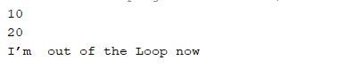

Results:

Repeat the same code using “continue” instead of “break”. Write down the output.

Answer:

package com.mycompany.practical1;

public class Practical1

{

public static void main(String[] args)

{

int [] numbers = {10, 20, 30, 40, 50};

for(int x : numbers )

{

if( x == 30 )

{

continue;

}

System.out.print( x );

System.out.print("\n");

}

System.out.print("I’m out of the Loop now");

}

}

Answer after execute the code:

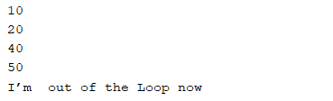

1. Write a class and insert the following code block into the appropriate place. Execute the code and get the result.
2. char grade =‘A’;
3. switch(grade)
4. {
5. case 'A' :
6. System.out.println("Excellent!");
7. break;
8. case 'D' :
9. System.out.println("You passed");
10. case 'F' :
11. System.out.println("Better try again");
12. break;
13. default :
14. System.out.println("Invalid grade");
15. }
16. System.out.println("Your grade is " + grade);

Answer:

package com.mycompany.practical1;

public class Practical1

{

public static void main(String[] args)

{

char grade ='A';

switch(grade)

{

case 'A' :

System.out.println("Excellent!");

break;

case 'D' :

System.out.println("You passed");

case 'F' :

System.out.println("Better try again");

break;

default :

System.out.println("Invalid grade");

}

System.out.println("Your grade is " + grade);

}

}

Answer after execute the code:

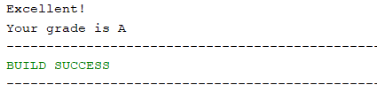

Results:

Repeat the same removing “break” command at line number .

Write down the output.

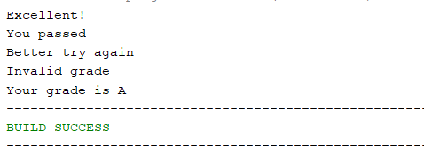

Repeat the same scenario by using if-else-if statement instead of switch case.

Answer:

package com.mycompany.practical1;

public class Practical1

{

public static void main(String[] args)

{

char grade='A';

if(grade=='A')

{

System.out.println("Excellent!");

}

else if(grade=='D')

{

System.out.println("You passed");

}

else if(grade=='F')

{

System.out.println("Better try again");

}

else

{

System.out.println("Invalid grade");

}

System.out.println("Your grade is " + grade);

}

}

1. As of java 5 the enhanced for loop was introduced. This is mainly used for Arrays. Below code contains few mistakes. First execute the code. Then identify the errors printed on the console. Rectify all the errors and execute to get the output:

class TestEnhanceForLoop {

public static void mains(String args[]){

int [] numbers = {10, 20, 30, 40, 50};

**for(int x : numbers ){**

**System.out.print( x );**

**System.out.print(",")**

**}**

System.out.print("\n");

String [] names ={“James”, "Larry", "Tom", "Lacy"}

**for( String name : names ) {**

**System.out.print( name );**

**System.out.print(",");**

Answer:

package com.mycompany.testenhanceforloop;

class TestEnhanceForLoop

{

public static void main(String args[])

{

int [] numbers = {10, 20, 30, 40, 50};

for(int x : numbers )

{

System.out.print( x );

System.out.print(",");

}

System.out.print("\n");

String [] names ={"James", "Larry", "Tom", "Lacy"};

for( String name : names )

{

System.out.print( name );

System.out.print(",");

}

}

}

Output:

